

**Touchstones**

***Netcards***

**Kindness Netcards with Text**

Act of Kindness HRJ

Appreciate HRJ

Being Kind HRJ

Birds HRJ

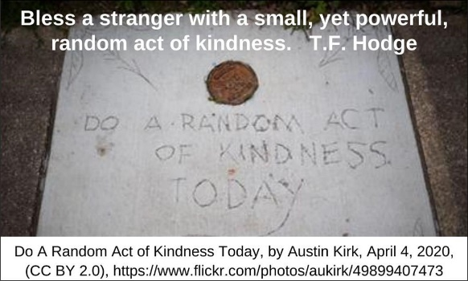

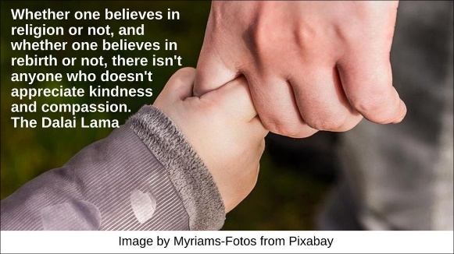

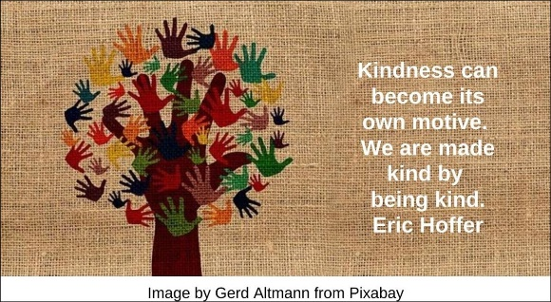

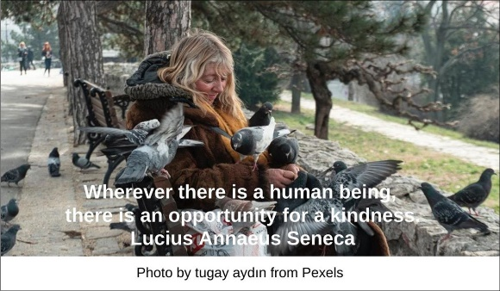

Children HRJ

Compassion HRJ

Dance for Joy HRJ

Enriches HRJ

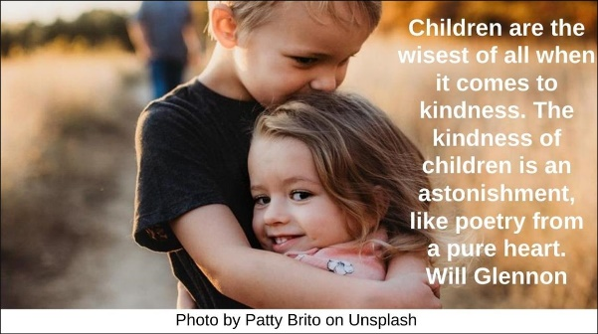





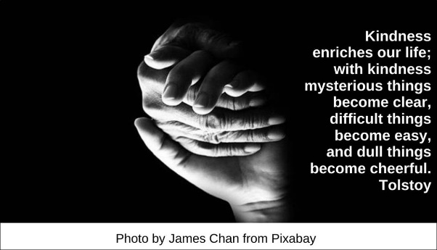

Flower HRJ

Heart Moon HRJ

Heaven HRJ

Hunger HRJ

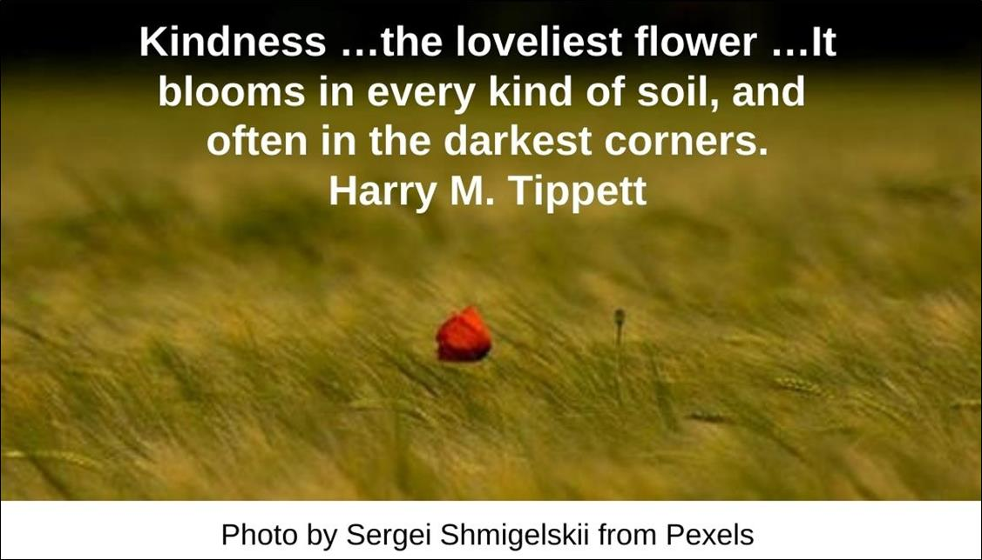



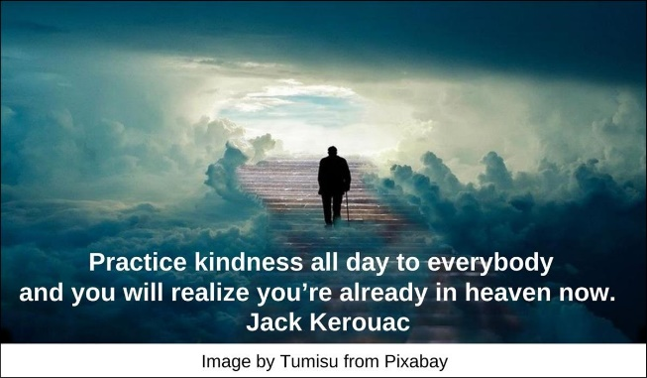

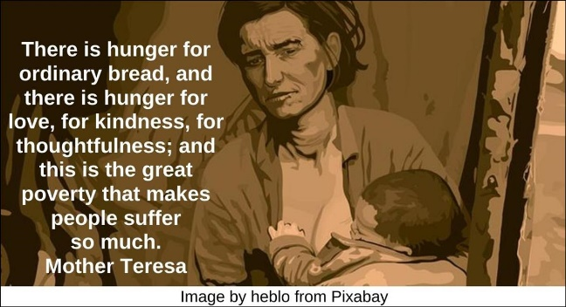

Ice Melting HRJ

Learning Kindness HRJ

Loving and Gentle HRJ

Loving Kindness HRJ

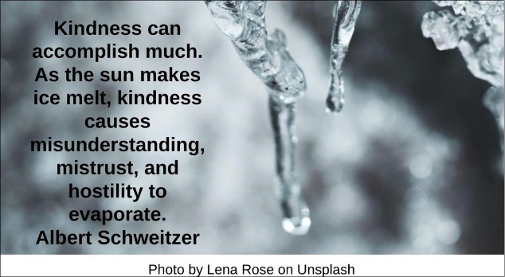

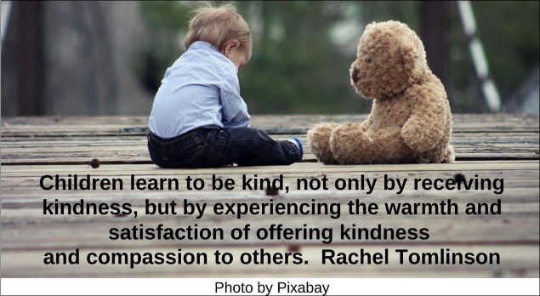

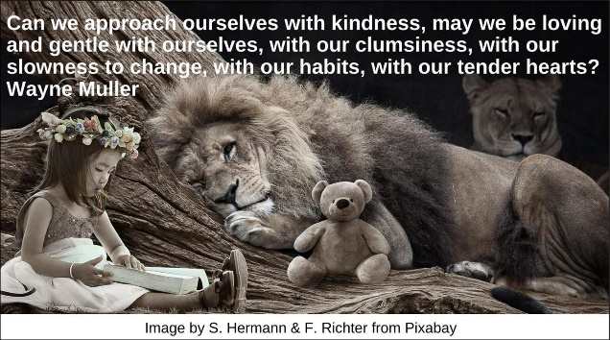

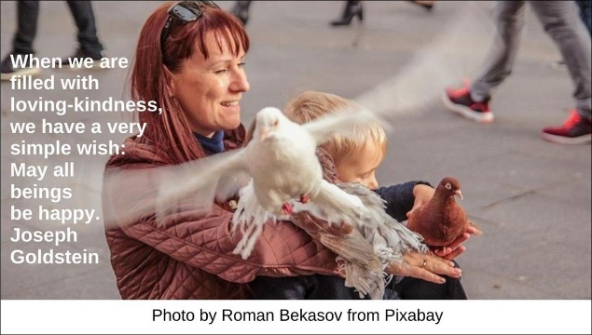

Nice HRJ

Peace HRJ

Practice HRJ

Rainbow Heart HRJ

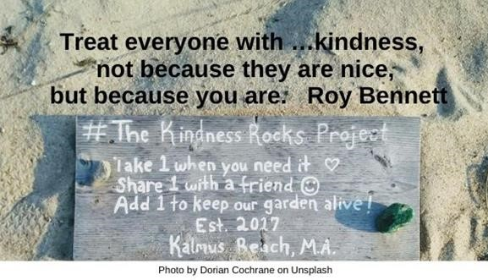

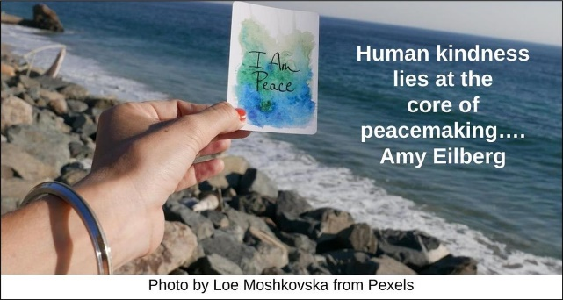

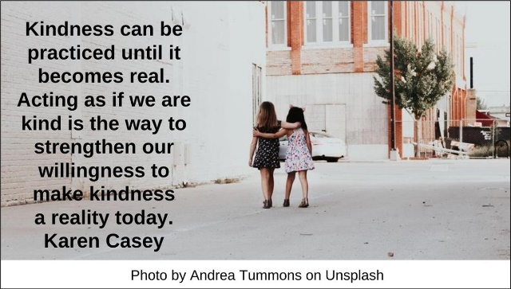



Random Act HRJ

Rebel HRJ

Regret HRJ

Roots HRJ

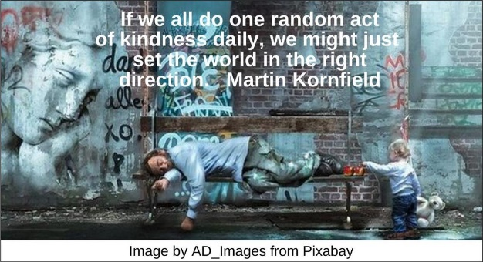

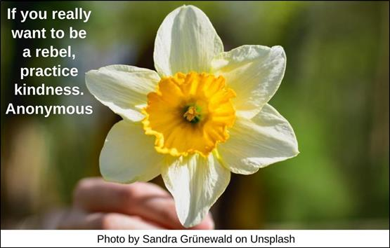

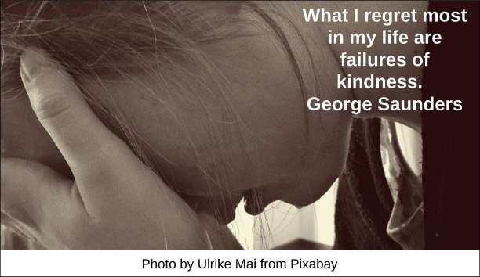

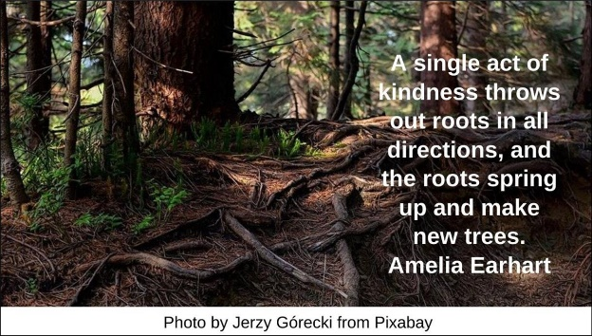

Sell By HRJ

Small HRJ

Sontag HRJ

Too Late HRJ

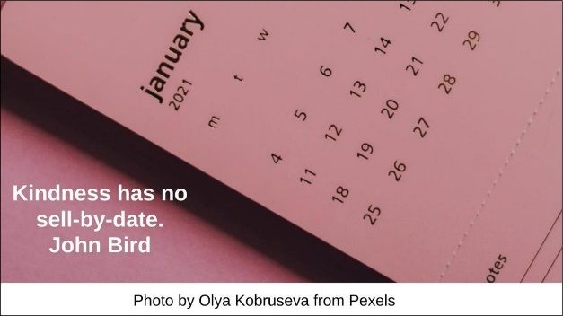

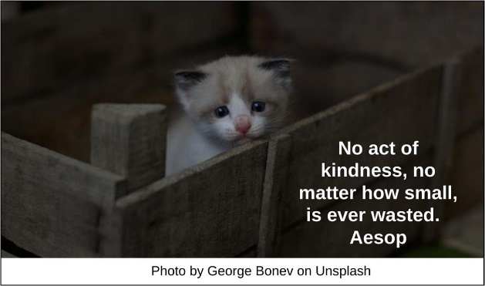



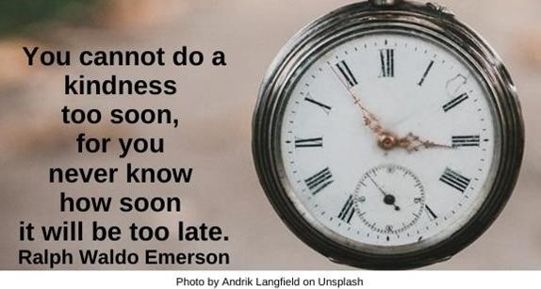

Vulnerable HRJ

Wisdom HRJ

Wonder HRJ

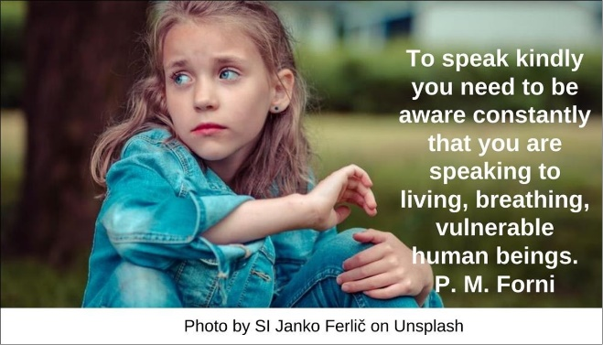



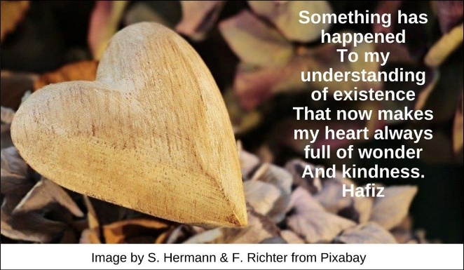

**Text of Quotes**

Act of Kindness HRJ

Bless a stranger with a small, yet powerful, random act of kindness. T.F. Hodge

Appreciate HRJ

Whether one believes in religion or not, and whether one believes in rebirth or not, there isn't anyone who doesn't appreciate kindness and compassion. The Dalai Lama

Being Kind HRJ

Kindness can become its own motive. We are made kind by being kind. Eric Hoffer

Birds HRJ

Wherever there is a human being, there is an opportunity for a kindness. Lucius Annaeus Seneca

Children HRJ

Children are the wisest of all when it comes to kindness. The kindness of children is an astonishment, like poetry from a pure heart. Will Glennon

Compassion HRJ

Compassion is literally feeling-with, or being-with. We are first and foremost fellow-humans. Mitsein. Kinfolk. Kindred flesh. It is this radical fellow-feeling that creates the impulse that flowers into kindness. Sam Keen

Dance for Joy

Any eye can threaten…., or …insult….; or in its altered mood, [its] beams of kindness …can make the heart dance for joy. Ralph Waldo Emerson

Enriches HRJ

Kindness enriches our life; with kindness mysterious things become clear, difficult things become easy, and dull things become cheerful. Tolstoy

Flower HRJ

Kindness …the loveliest flower …It blooms in every kind of soil, and often in the darkest corners. Harry M. Tippett

Heart Moon HRJ

Our acts of kindness … return us once again to the heart of our own humanity. Will Glennon

Heaven HRJ

Practice kindness all day to everybody and you will realize you’re already in heaven now. Jack Kerouac

Hunger HRJ

There is hunger for ordinary bread, and there is hunger for love, for kindness, for thoughtfulness; and this is the great poverty that makes people suffer so much. Mother Teresa

Ice Melting HRJ

Kindness can accomplish much. As the sun makes ice melt, kindness causes misunderstanding, mistrust, and hostility to evaporate. Albert Schweitzer

Learning Kindness HRJ

Children learn to be kind, not only by receiving kindness, but by experiencing the warmth and satisfaction of offering kindness and compassion to others. Rachel Tomlinson

Loving and Gentle HRJ

Can we approach ourselves with kindness, may we be loving and gentle with ourselves, with our clumsiness, with our slowness to change, with our habits, with our tender hearts? Wayne Muller

Loving Kindness HRJ

When we are filled with loving-kindness…, we have a very simple wish: May all beings be happy. Joseph Goldstein

Nice HRJ

Treat everyone with …kindness, not because they are nice, but because you are. Roy Bennett

Peace HRJ

Human kindness lies at the core of peacemaking…. Amy Eilberg

Practice HRJ

Kindness can be practiced until it becomes real. Acting as if we are kind is the way to strengthen our willingness to make kindness a reality today. Karen Casey

Rainbow Heart HRJ

We ask a heart of compassion and gentle hands and kindly words. Albert Schweitzer

Random Act HRJ

If we all do one random act of kindness daily, we might just set the world in the right direction. Martin Kornfield

Rebel HRJ

If you really want to be a rebel, practice kindness. Anonymous

Regret HRJ

What I regret most in my life are failures of kindness. George Saunders

Roots HRJ

A single act of kindness throws out roots in all directions, and the roots spring up and make new trees. Amelia Earhart

Sell By HRJ

Kindness has no sell-by-date. John Bird

Small HRJ

No act of kindness, no matter how small, is ever wasted. Aesop

Sontag HRJ

Kindness, kindness, kindness. Susan Sontag, diary entry, January 1, 1972

Too Late HRJ

You cannot do a kindness too soon, for you never know how soon it will be too late. Ralph Waldo Emerson

Vulnerable HRJ

To speak kindly you need to be aware constantly that you are speaking to living, breathing, vulnerable human beings. P. M. Forni

Wisdom HRJ

The highest wisdom is kindness. Berakot

Wonder HRJ

Something has happened  
To my understanding of existence  
That now makes my heart always full of wonder  
And kindness. Hafiz